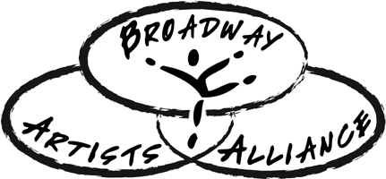

From [YOUR TOWN] to New York!
[YOUR NAME] has been accepted to Broadway Artists Alliance of New York City!
Broadway Artists Alliance of New York City is an elite, audition-based program that provides professional training for young musical theatre performers. The program is uniquely situated in the heart of New York City, and offers classes taught by Tony Award winners, Broadway performers and New York’s top casting directors, agents, coaches and choreographers. Candidates audition to be voice, acting, or dance majors and, if accepted, get to study in New York City with other students from around the country and overseas.
Broadway Artists Alliance students work to develop their “Triple Threat” performance skills while learning about the business of acting and making connections with industry professionals. They also perform in a final industry showcase for top NYC Agents, Managers and Casting Directors.
Students receive group instruction and private coaching in disciplines including audition technique, song interpretation, monologue work, scene study, on-camera acting, and musical theatre dance from instructors including Tony Award Winners Jessie Mueller, Kelli O’Hara, Sutton Foster, Alice Ripley, Christian Borle and Jason Robert Brown, and Broadway and TV professionals as Jeremy Jordan, Lea Michele, Megan Hilty, Kyle Dean Massey and more!
Broadway Artists Alliance’s alumni can be seen on Broadway, in National Tours, on Television, and in Film. Past students include Grammy Nominee Ariana Grande, Broadway’s Casey Butler (Finding Neverland) Kyle Taylor Parker (Kinky Boots, Charlie and the Chocolate Factory), Clay Thomson (Newsies, Matilda), Emerson Steele (Violet) and Emma Howard (Matilda, Violet and The Beguiled film), just to name a few. BAA Alumni currently on Broadway include Nala Hamilton, Zach Thomas, and Rika Nishikawa (The Lion King), Ryan Foust (Charlie and The Chocolate Factory), Sammy Bray (1984) and Hillary Porter (A Bronx Tale)!
[Your name] was most recently seen has the role of [last character you played] in [show] at [Name of Theatre] in [City and State]. [He/She] is excited to take the next step of [his/her] career by heading to New York City! Congratulations to [Your name] and all the luck on [his/her] new adventure. Broadway here we come!

To learn more about [Your Name], what she will be experiencing with Broadway Artists Alliance, and how you can also be part of the adventure, visit our website at www.broadwayartistsalliance.org, or contact us via social media through @BAAofNYC in Instagram and Twitter, and on Facebook at fb.me/BroadwayArtistsAlliance

